**Scientific Inquiry Practice**

**Partners**

**Delephene, Loz, Matthew, and Maddie - String Length**

**Purpose:** the purpose of this activity is to practice the scientific inquiry process.

**Directions**:

1. Read the procedure and basic design of the lab shown in the diagram.
2. You will follow the scientific inquiry process and design your own experiment.
3. You will measure the period of a pendulum
4. You will watch a [video](https://www.youtube.com/watch?v=02w9lSii_Hs) and demonstration of a pendulum and identify variables that might impact the period of the pendulum.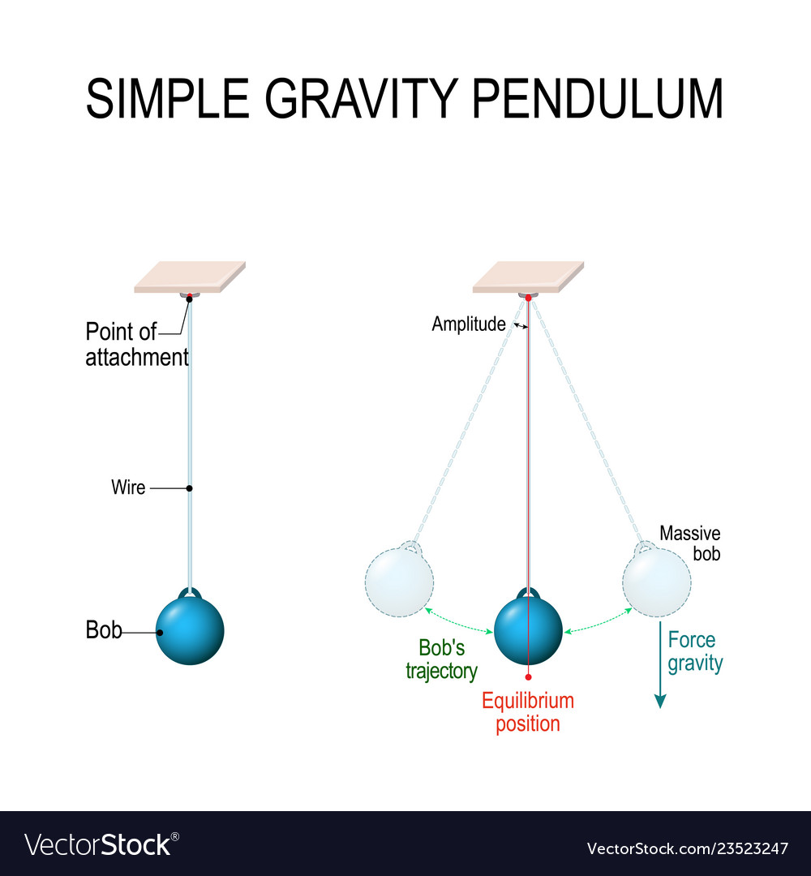

**Materials Available**

Ring stand

string of various lengths and types

washers (masses) (bobs)

ruler

stopwatch

**Engage Phase**

**-after completing steps 1-3 above, answer the following questions:**

1. What factors affect the period of a pendulum's swing? **The length of the string and the mass of the ball. If the string is shorter or not or the ball.**
2. Define period as related to the pendulum's swing? **How long the string is or how short it is. Or the time it takes. The mass affects it because the weight on the string is carrying the ball, so it is a shorter distance because of the weight.**
3. If you time the pendulum swing 10 times, then how do you calculate the period for one swing? **You divide how long it took to swing ten times and divide it by ten and your answer is whatever is left over.**
4. What variables affect the swing time of a pendulum? **The length of the string and the ball.**



**Explore**

| **Step** | **Elaboration** | **Explain** |
| --- | --- | --- |
| 1. **Make an Observation** | **What did you observe about the pendulums?** | When I watched the pendulums, the shorter string with the ball attached went faster for ten seconds, but the long one went slower. |
| 1. **Asking a Question** | **What question are you attempting to answer?**  What is the effect of ….. on the period of a pendulum? | I am trying to answer whether the mass is affecting the swing or the string's length.  The effect of the distance is caused by either mass, gravity, or the string’s length. |
| **Can your question be answered through an experiment? Explain.** | Yes because the mass pushes the string down and the ball too because of gravity and when they push the ball with a longer string it goes a longer distance but with a shorter string it goes a shorter distance but faster. |
| **Background Research** | **Definitions:**  **period**  **oscillation** | Period: Time period of a pendulum depends on the length of the pendulum.  Oscillation: Oscillation is a motion that repeats regularly on a daily basis. |
| 1. **Forming a Hypothesis** | **Create a hypothesis using the following format:**  As ramp height increases, the speed of the car across the floor decreases because of friction.  If ramp height is increased, then the speed of the car across the floor will decrease. | **As string length increases, the period will increase because when the string is long there is more distance to cover.** |
| **2. Prediction:**  **If...then… statement.** | **I predict that the string when it is increased the period of the pendulum will increase by negative two. When the length is longer the spring lifting the ball will go a longer distance, but slower.** |
| **Is your hypothesis testable? How?**  **Is your hypothesis falsifiable? How?** | It is testable because when you push the ball with a shorter string the distance is shorter and the speed is longer.  It is falsifiable because if the string is cut it could ruin the experiment. |
| 1. **Testing the hypothesis** | **Responding variable = period of pendulum swing** | **period of pendulum swing** |
| **Manipulated variable =** | **string length** |
| **Controlled variables =** | **Weight of the ball, drop height, and string width** |
| **Replication = (describe how and why you will replicate this experiment)** | **To test our experiment and hypothesis we will do three different drops with different string length at different heights and see which is the best out of all of them.** |

Collect Data in your lab journal and then type into a separate document.

Steps 5-7 in Lab Pendulum Data document

Space for brainstorming experimental design and data table: